Excel 2007

Working with cells

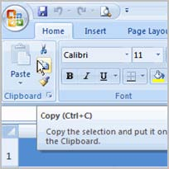

It is important to know how to **move information** from one cell to another in Excel. Learning the various ways will **save you time** and make working with Excel easier. Certain methods are more appropriate depending on how much information you need to move and where it will reside on the spreadsheet. In this lesson you will learn how to **cut**, **copy**, and **paste**, as well as **drag** and **drop** information.

**To Copy and Paste Cell Contents:**

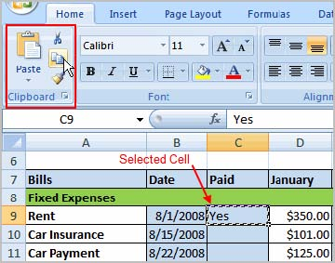

Select the **cell or cells** you wish to **copy**.

Click the **Copy** command in the Clipboard group on the Home tab. The border of the selected cells will change appearance.

Select the **cell or cells** where you want to **paste** the information

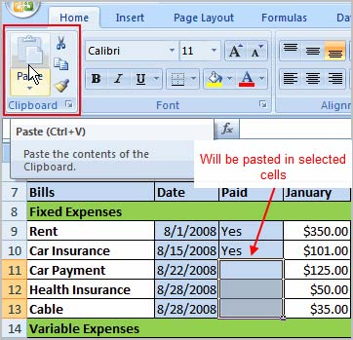Cick the **Paste** command. The copied information will now appear in the new cells.

To select **more than one adjoining cell**, left-click one of the cells, drag the cursor until all the cells are selected, and release the mouse button.

The copied cell will **stay selected** until you perform your next task, or you can double-click the cell to **deselect** it.

**To Cut and Paste Cell Contents:**

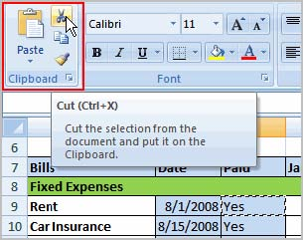

Select the **cell or cells** you wish to **copy**.

Click the **Cut** command in the Clipboard group on the Home tab. The border of the selected cells will change appearance.

Select the **cell or cells** where you want to **paste** the information.

Click the **Paste** command. The cut information will be removed from the **original cells** and **now appear** in the new **cells**.

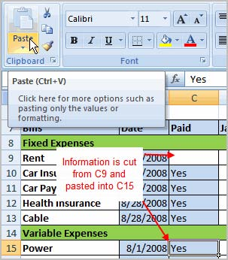

The keyboard shortcut for Paste is the **Control Key** and the **V** key.

**To Drag and Drop Information:**

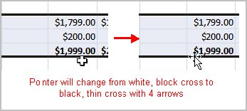

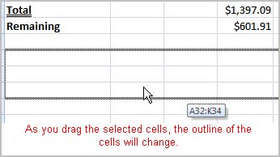

Select the **cell or cells** you wish to move.

Position your **mouse pointer** near one of the **outside edges** of the selected cells. The mouse pointer changes from a **large, white cross** to a **black cross with 4 arrows**.

Left-click and **hold** the mouse button and **drag** the cells to the new location.

Release the mouse button and the information appears in the new location.

**To Use the Fill Handle to Fill Cells:**

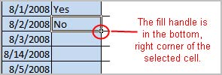Position your cursor over the **fill handle** until the large white cross becomes a thin, black cross.

Left-click your mouse and **drag it** until all the cells you want to fill are highlighted.

Release the mouse button and all the selected cells are filled with the information from the original cell.

The fill handle doesn't **always** copy information from one cell directly into another cell. Depending on the data entered in the cell, it may fill the data in other ways. For example, if I have the formula =A1+B1 in cell C1, and I use the fill handle to fill the formula into cell C2, the formula doesn't appear the same in C2 as it does in C1. Instead of =A1+B1, you will see =A2+B2.

You can use the fill handle to fill cells horizontally or vertically.

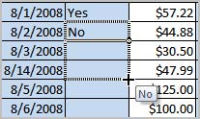

**Preparing to Print and Printing**

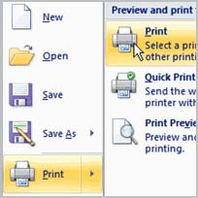

In Excel, there are many things you can do to prepare your workbook for printing. Many of these tasks make it easier to **format the spreadsheet** for the printed page.

In this lesson you will learn how to view the spreadsheet in print preview, modify margins, change the page orientation, use the scale to fit feature, use the Print Titles command, insert breaks, and more.

**To View the Spreadsheet in Print Preview:**

Left-click the **Microsoft Office Button**.

Select **Print**.

Select **Print Preview**. The spreadsheet will appear in Print Preview view.

Click the **Close Print Preview** button to return to the Normal View.

To make previewing your spreadsheet easier, add the **Print Preview** command to the Quick Access toolbar.

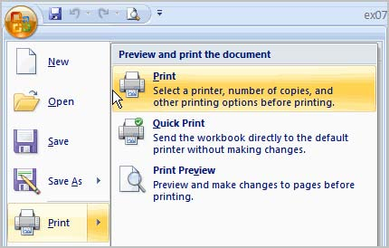

**Exploring Print Preview:**

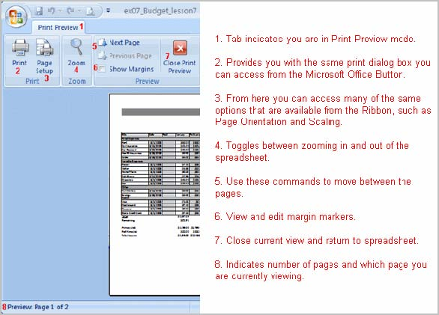Once you are in Print Preview, you can access many of the same features that you can from the Ribbon; however, in Print Preview you can see how the spreadsheet will appear in printed format.

**To Modify Margins, Column Width, or Row Height While in Print Preview:**

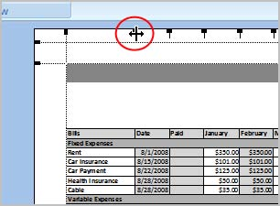

Click the **Print Preview** command on the Quick Access toolbar, or select Print Preview from the Microsoft Office Button menu. The spreadsheet opens in print preview mode.

Hover your cursor over one of the **black margin markers** until a **double arrow** appears.

9/30/2010 1:53 PM

Left-click and drag the marker to the desired location. The change will be reflected in the spreadsheet.

**To Modify Margins:**

Select the **Page Layout** tab.

Left-click the **Margins** command.

Choose one of the predefined settings or enter custom margins.

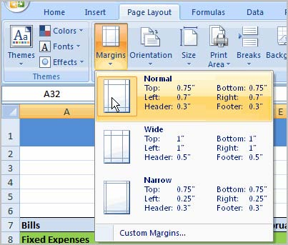

**To Change Page Orientation:**

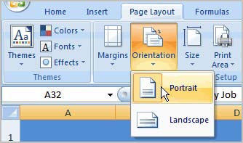

Select the **Page Layout** tab.

Left-click the **Orientation** command.

Select either Portrait or Landscape.

**Portrait** orients the page **vertically**, while **Landscape** orients the page **horizontally**.

**To Use Scale to Fit:**

Select the **Page Layout** tab.

Locate the Scale to Fit group.

Enter a specific **height** and **width**, or use the percentage field to decrease the spreadsheet by a specific percent.

Scale to Fit is a useful feature that can help you format spreadsheets to fit on a page. Be careful with how small you scale the information -- it can become difficult to read!

**To Change the Paper Size:**

Select the **Page Layout** tab.

Click the **Size** command.

Select a size option from the list.

**To Define a Print Area:**

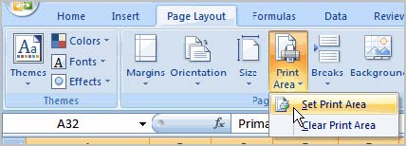Left-click and drag your mouse to **select the cells** you wish to print.

Click the **Print Area** command.

Choose **Set Print Area**.

Now, only the selected cells will print. You can confirm this by viewing the spreadsheet in Print Preview.

To return to the default setting, which is the entire worksheet, click the Print Area command and select Clear Print Area.

**To Insert a Break:**

Select a cell **below** where you want the break to appear.

Select the **Breaks** command.

Select **Insert Break**. Click Print Preview to confirm the break appears in the correct place in your spreadsheet.

**To Use the Print Titles command:**

This is an important command to be familiar with if you intend to print your worksheets. It allows you to select **specific rows** and/or **columns** to appear on **each** printed sheet. Imagine how difficult it would be to read page 48 of a printed spreadsheet if the column and row headings only appeared on the first page.

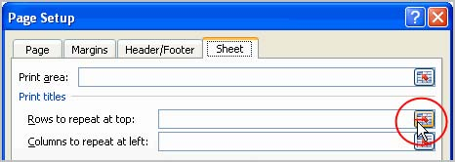Select the **Page Layout** tab.

Click the **Print Titles** command. The Page Setup dialog box appears.

Click the icon at the end of the field.

Select the first row in the spreadsheet that you want to appear on **each printed page**.

Repeat for the column, if necessary.

Click OK.

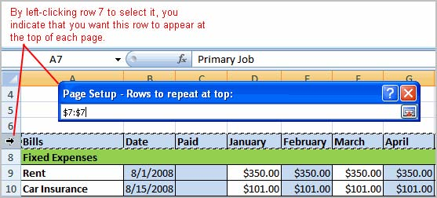

**To Print from the Microsoft Office Button:**

Left-click the **Microsoft Office Button**.

Select **Print**

**Print**. The Print dialog box appears.

Select a printer if you wish to use a printer other than the default setting.

Click **Properties** to change any necessary settings.

Choose whether you want to print specific pages, all of the worksheet, a selected area, the active sheet, or the entire workbook.

Select the number of copies you'd like to print.

Click **OK**. You can select **Quick Print** to bypass the Print dialog box.



**Creating complex formulas**

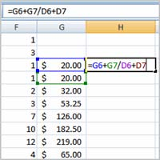

Excel is a spreadsheet application and is intended to be used to **calculate** and **analyze numerical information** such as household budgets, company finances, inventory, and more. To do this, you need to understand **formulas**.

In this lesson, we’ll discuss **complex formulas** that use multiple mathematical operators, and that use **absolute** and **relative references**.

**Complex Formulas Defined**

Simple formulas have **one** mathematical operation. **Complex formulas** involve **more than one** mathematical operation.

**Simple Formula:** =2+2

**Complex Formula:** =2+2*8

To calculate complex formulas correctly, you must perform certain operations before others. This is defined in the **order of operations**.

**The Order of Operations**

The order of mathematical operations is very important. If you enter a formula that contains several operations, Excel knows to work those operations in a specific order. The **order of operations** is:

1. Operations enclosed in parenthesis
2. Exponential calculations (to the power of)
3. Multiplication and division, whichever comes first
4. Addition and subtraction, whichever comes first A mnemonic that can help you remember this is **P**lease **E**xcuse **M**y **D**ear **A**unt **S**ally (P.E.M.D.A.S).

**Example 1** Using this order, let us see how the formula **20/(8-4)*8-2** is calculated in the following breakdown:

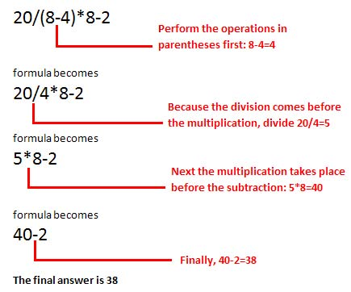

**Example 2**

**3+3*2=?**

Is the answer 12 or 9? Well, if you calculated in the order in which the numbers appear, 3+3*2, you'd get the wrong answer, 12. You must follow the order of operations to get the correct answer.

**To Calculate the Correct Answer:**

1. Calculate 3*2 first because **multiplication** comes **before addition** in the order of operations. The answer is 6.
2. Add the answer obtained in step #1, which is 6, to the number 3 that opened the equation. In other words, add 3 + 6.
3. The answer is 9.

Before moving on, let's explore some more formulas to make sure you understand the order of operations by which Excel calculates the answer.

**4*2/4 Multiply** 4*2 **before** performing the **division** operation because the multiplication sign comes before the division sign. The answer is 2.

**4/2*4 Divide** 4 by 2 **before** performing the **multiplication** operation because the division sign comes before the multiplication sign. The answer is 8.

**4/(2*4)** Perform the operation in **parentheses** (2*4) first and **divide** 4 by this result. The answer is 0.5.

**4-2*4 Multiply** 2*4 before performing the **subtraction** operation because the multiplication sign is of a higher order than the subtraction sign. The answer is -4.

**Creating Complex Formulas**

Excel **automatically** follows a **standard order of operations** in a complex formula. If you want a certain portion of the formula to be calculated first, put it in parentheses.

**Example of How to Write a Complex Formula:**

Click the cell where you want the formula **result** to appear. In this example, H6.

Type the equal sign (=) to let Excel know a formula is being defined.

Type an open parenthesis, or (

Click on the **first cell** to be included in the formula (G6, for example).

Type the **addition sign (+)** to let Excel know that an add operation is to be performed.

Click on the **second cell** in the formula (G7, for example)

Type a close parentheses ).

Type the next mathematical operator, or the **division symbol (/)** to let Excel know that a division operation is to be performed.

Type an open parenthesis, or (

Click on the **third cell** to be included in the formula (D6, for example).

Type the **addition sign (+)** to let Excel know that an add operation is to be performed.

Click on the **fourth cell** to be included in formula. (D7, for example).

Type a close parentheses ).

**Very Important:** Press **Enter** or click the **Enter button** on the Formula bar. This step ends the formula.

To show fewer decimal places, you can just click the **Decrease Decimal** place command the Home tab.

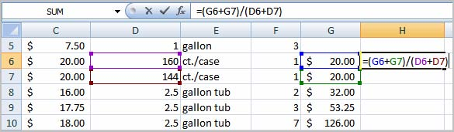

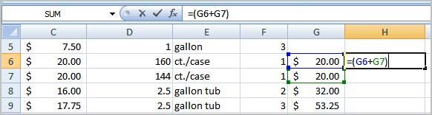

**What is an Absolute Reference?**

In earlier lessons we saw how **cell references** in formulas **automatically adjust** to new locations when the formula is pasted into different cells. This is called a **relative reference**.

Sometimes, when you copy and paste a formula, you don't want one or more cell references to change. **Absolute reference** solves this problem. **Absolute cell references** in a formula **always** refer to the **same cell** or cell range in a formula. If a formula is copied to a different location, the absolute **reference** remains the same.

An absolute reference is designated in the formula by the addition of a **dollar sign ($)**. It can precede the column reference or the row reference, or both. Examples of absolute referencing include:

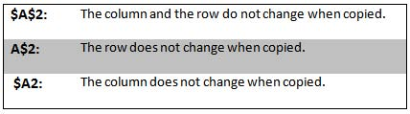

**To Create an Absolute Reference:**

Select the cell where you wish to write the formula (in this example, H2)

Type the equal sign (=) to let Excel know a formula is being defined.

Click on the **first cell** to be included in the formula (F2, for example).

Enter a mathematical operator (use the multiplication symbol for this example).

Click on the **second cell** in the formula (C2, for example).

Add a $ sign before the C and a $ sign before the 2 to create an absolute reference.

Copy the formula into H3. The new formula should read =F3*$C$2. The F2 reference changed to F3 since it is a relative reference, but C2 remained constant since you created an absolute reference by inserting the dollar signs.

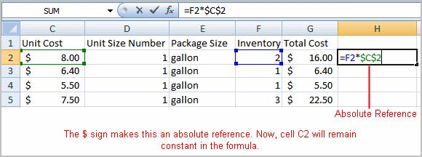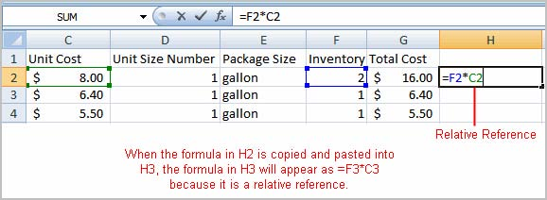

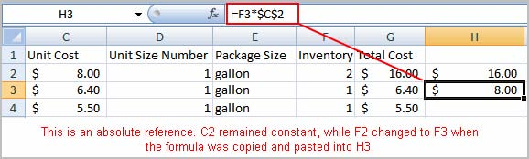

**Working with charts**

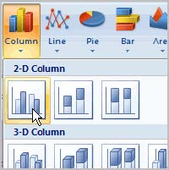A **chart** is a tool you can use in Excel to communicate your **data graphically**. Charts allow your audience to more easily see the meaning behind the numbers in the spreadsheet, and make showing comparisons and trends a lot easier. In this lesson, you will learn how to **insert** and **modify** Excel charts and see how they can be an effective tool for communicating information.

Charts can be a useful way to communicate data. When you insert a chart in Excel, it appears in the selected worksheet with the source data, by default.

**To Create a Chart:**

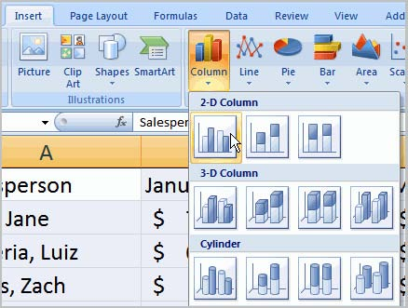

Select the **worksheet** you want to work with. In this example, we use the **Summary** worksheet.

Select the **cells** that you want to chart, including the **column titles** and the **row labels**.

Click the **Insert** tab.

Hover over each **Chart option** in the Charts group to learn more about it.

Select one of the Chart options. In this example, we use the Columns command.

Select a **type of chart** from the list that appears. For this example, we use a 2-D Clustered Column. The chart appears in the worksheet.

**Identifying the Parts of a Chart**

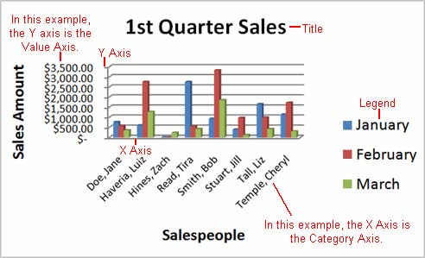Have you ever read something you didn't fully understand but when you saw a chart or graph, the concept became clear and understandable? Charts are a **visual representation** of data in a worksheet. Charts make it easy to see comparisons, patterns, and trends in the data.

**Source Data**

The range of cells that make up a chart. The chart is updated automatically whenever the information in these cells change.

**Title**

The title of the chart.

**Legend**

The chart key, which identifies each color on the chart represents.

**Axis**

The vertical and horizontal parts of a chart. The vertical axis is often referred to as the Y axis, and the horizontal axis is referred to as the X axis.

**Data Series**

The actual charted values, usually rows or columns of the source data.

**Value Axis**

The axis that represents the values or units of the source data.

**Category Axis**

The axis identifying each data series.

**Chart Tools**

Once you insert a chart, a new set of **Chart Tools**, arranged into 3 tabs, will appear above the Ribbon. These are only visible when the chart is selected.

**To Change the Chart Type:**

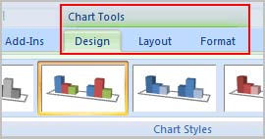Select the **Design** tab.

Click the **Change Chart Type** command. A dialog box appears.

Select another **chart type**.

Click OK.

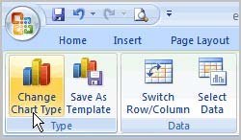The chart in the example compares each salesperson's monthly sales to his/her other month's sales; however you can change what is being compared. Just click the **Switch Row/Column Data** command, which will rotate the data displayed on the **x** and **y axes**. To return to the **original view**, click the Switch Row/Column command again.

**To Change Chart Layout:**

Select the **Design** tab.

Locate the **Chart Layouts** group.

Click the **More** arrow to view all your layout options.

Left-click a layout to select it.

If your new layout includes chart titles, axes, or legend labels, just insert your cursor into the text and begin typing to add your own text.

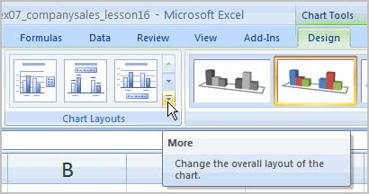

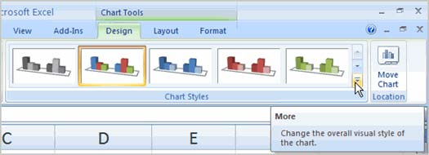**To Change Chart Style:**

Select the **Design** tab.

Locate the **Chart Style** group.

Click the **More** arrow to view all your style options.

Left-click a style to select it.

**To Move the Chart to a Different Worksheet:**

Select the **Design** tab.

Click the **Move Chart** command. A dialog box appears. The current location of the chart is selected.

Select the desired location for the chart (i.e., choose an existing worksheet, or select New Sheet and name it).

